Direct or indirect proportion

- If 6 copies of a book cost €90, calculate the cost of 8 books.

- As the number of …………. go ……….., the costs go …………….. It is a/an …………………….. proportion
- 4 people can paint a fence in 3 hours. How long will it take 6 people to paint it?
- As the number of people goes …………., the painting time ………………………...

How many people are needed to complete the job in half an hour?
- It takes 4 men 6 hours to repair a road. How long will it take 8 men to do the job if they work at the same rate?
- If 25 lollies cost €5.50, calculate the cost of 11 lollies. I or D? If 5 tickets for a play cost €40, calculate the cost of: (a) 6 tickets (b) 9 tickets (c) 20 tickets.

- To make 3 glasses of orange squash you need 600 ml of water. How much water do you need to make: I or D? (a) 5 glasses of orange squash, (b) 7 glasses of orange squash?

- If 10 litres of petrol cost € 9.20, calculate the cost of: (a) 4 litres (b) 12 litres (c) x litres.
- A baker uses 1800 grams of flour to make 3 loaves of bread. How much flour will he need to make:
(a) 2 loaves (b) y loaves (c) 24 loaves?
- Ben buys 21 football stickers for 84c. Calculate the cost of:
(a) 7 stickers (b) 12 stickers (c) 50 stickers.

- 16 teams, each with the same number of people, enter a quiz. At the semifinal stage there are 12 people left in the competition. How many people entered the quiz?

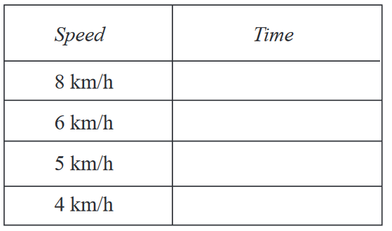
- Three identical coaches can carry a total of 162 passengers. How many passengers in total can be carried on seven of these coaches?

- Joshua runs home from school, a distance of 8 km. Complete the table below to show the times he takes if he runs at different speeds.

- If 7 electricians can wire some new houses in 17 days, how many electricians would be required to do the job in 9 days?
- Jane can type at 6o words a minute and took 35minutes to complete a letter. How long would John take who types at 43 words a minute?
- A car travelling at 45km/hr takes 33 minutes for a journey. How long does a car travelling at 55km/h take for the same journey?
- If there are 6 builders, it takes 80 days to complete the house. How many builders must be employed to build the house in just 16 days? □ 1.2 builders □ 25 builders □30 builders □ 36 builders

- The time taken to dig a hole is ………………………….. proportional to the number of people doing the digging. It takes 4 people 6 hours to dig the hole. How long will it take 8 people to dig a hole?

